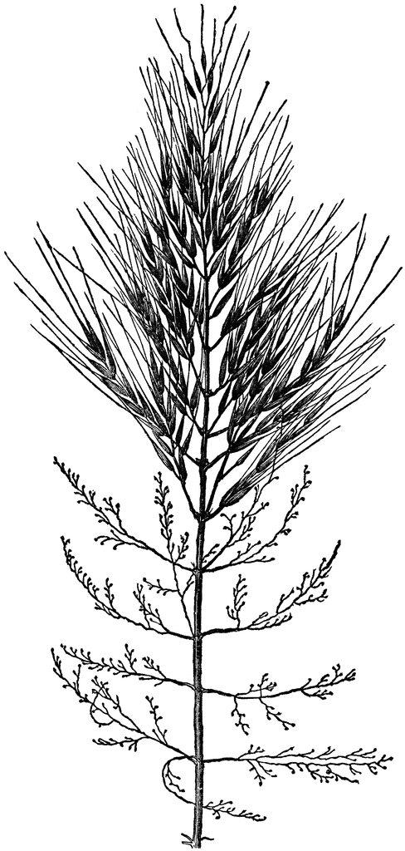
Wild Rice
Sovereign Food
Reserved Treaty Right
Protect The Ceded Lands
For The Seventh Generation
For more information, visit www.protectourmanoomin.org
Wild Rice
Sovereign Food
Reserved Treaty Right
Protect The Ceded Lands
For The Seventh Generation
For more information, visit www.protectourmanoomin.org

Wild Rice
Sovereign Food
Reserved Treaty Right
Protect The Ceded Lands
For The Seventh Generation
For more information, visit www.protectourmanoomin.org

