**1837 Treaty Quote**

*“This Straw which I hold in my hands, Wild Rice is what we call this. These I do not sell. That you may not destroy the Rice in working the Timber, Also the Rapids and Falls in the Streams I will lend you to saw your timber....I do not make you a present of this, I merely lend it to you."*

**What is Sulfide Mining?**

Sulfide ores are ores containing heavy metals (such as copper or nickel) that are bonded to sulfur, forming sulfur minerals. When exposed to air and moisture, a chemical reaction generates sulfuric acid that can be leach into the surrounding environment and cause the release of the metals into streams and lakes at levels that are toxic to fish and other aquatic life. This is known as Acid Mine Drainage (AMD).

In a surface mine…mining leaves huge piles of waste rock and a huge pit exposed to the elements. The waste rock and the pit walls contain sulfide materials. The potential for AMD and for contamination of surface and ground water by heavy metals remains for centuries.

Website:

http://www.protectourmanoomin.org

Facebook:

<http://www.facebook.com/groups/>

protectourmanoomin

Email:

r_desjarlait@protectourmanoomin.org

Phone:

612.600.2526

**Protect Our Manoomin**

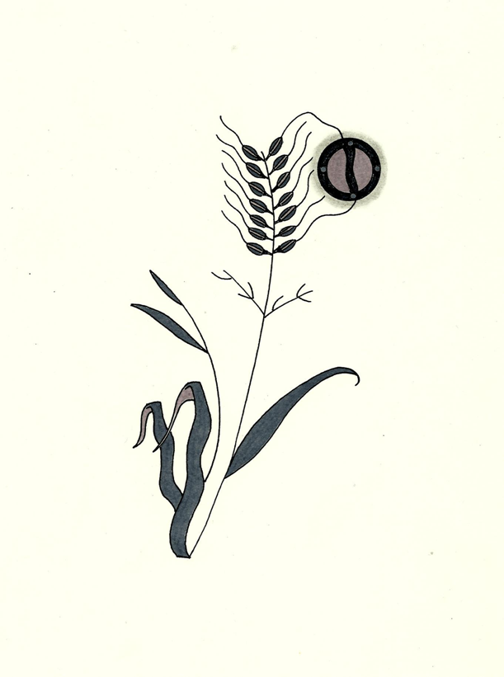

Protect Our Manoomin is a nonprofit organization. Our mission is to educate and inform on issues related to manoomin in regard to mining and environmental ethics. If you would like to schedule a speaker or a informational display, please contact at our email or phone. Mii’gwech.

**The Effects of Sulfate on Manoomin**

In water, sulfuric chemicals are converted into sulfate. Once sulfates get into the sediments at the bottoms of streams and lakes, microbes convert the sulfates back into sulfides and hydrogen sulfide is formed. Hydrogen sulfide interferes with the development of the roots of manoominaganzhiin, (wild rice plants), and the stunted roots starve the rest of the plants of nitrogen. This results in fewer and smaller seeds, and the leaves turn yellow. Hydrogen sulfide affects both seeds and root symptoms of manoomin year-round. High levels of sulfate/hydrogen sulfide suffocate and kill the manoominaganzh (wild rice plant).

**Protect Our Manoomin**

**For the present generation**

**to the Seventh Generation**

**Article 2.**

**Obligations of Protect Our Manoomin**

1. We believe that manoomin is a sacred being with inherent rights. As such:
2. We oppose sulfide mining that will gravely impact manoomin and the ecosystem of northern Minnesota;
3. We oppose legislative policies that endanger manoomin;
4. We demand a miming moratorium until the Minnesota Pollution Control Agency completes its study on manoomin;
5. We oppose the environmental racism that guides the policies of state agencies favoring mining interests;
6. We demand redress for the environmental injustice committed against the inherent rights of manoomin as stated in Article 1;
7. We oppose the ecocide of Omizakamigokwe (Mother Earth).

**Article 3.**

**Guiding Principal**

We will protect our manoomin for the present generation to the Seventh Generation.

**Article 1.**

**Inherent Rights of Manoomin**

1. As a living being, manoomin has the following inherent rights:
2. the right to life and to exist;
3. the right to be respected;
4. the right to regenerate its bio-capacity and to continue its vital cycles and processes free from human disruptions;
5. the right to maintain its identity and integrity as a distinct, self-regulating and interrelated being;
6. the right to sacred nibi (water) as a source of life;
7. the right to integral health;
8. the right to be free from toxic pollution resulting from sulfide mining;
9. the right to not have its genetic structure modified or disrupted in a manner that threatens its integrity or vital and healthy functioning.
10. Manoomin has the right to a place and to play its role in Omizakamigokwe (Mother Earth) for her harmonious functioning

**Protect Our Manoomin**

**(Weweni Ganawendan Gi-Manoomininaan)**

**Protect Our Manoomin** believes that manoomin (wild rice) is a sustenance gift from Gichi-Manidoo (the Creator). In this respect, the sustenance right to manoomin is sacred and cannot be constrained or recalled by colonial laws, policies, or institutions that impact and imperil the manoomin gitigaanan (natural wild rice stands) and gaa-izhi-maamawi-bimaadag (ecosystem) in northern Minnesota. We are resolved, as Bamaadizidjig (Anishinaabeg, non-Anishinaabeg, and non-Native peoples), to resist any changes that endanger our manoomin. We seek to create awareness of sulfate and sulfide pollution via mining and its harmful effects on manoomin – a vital cultural, spiritual, and environmental resource. We are guided by the Anishinaabe gete-gikendaasowin (traditional knowledge) of our elders.

N'miigwetchwaanaami