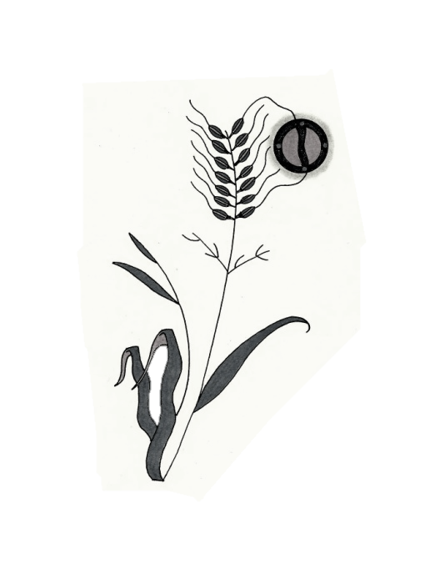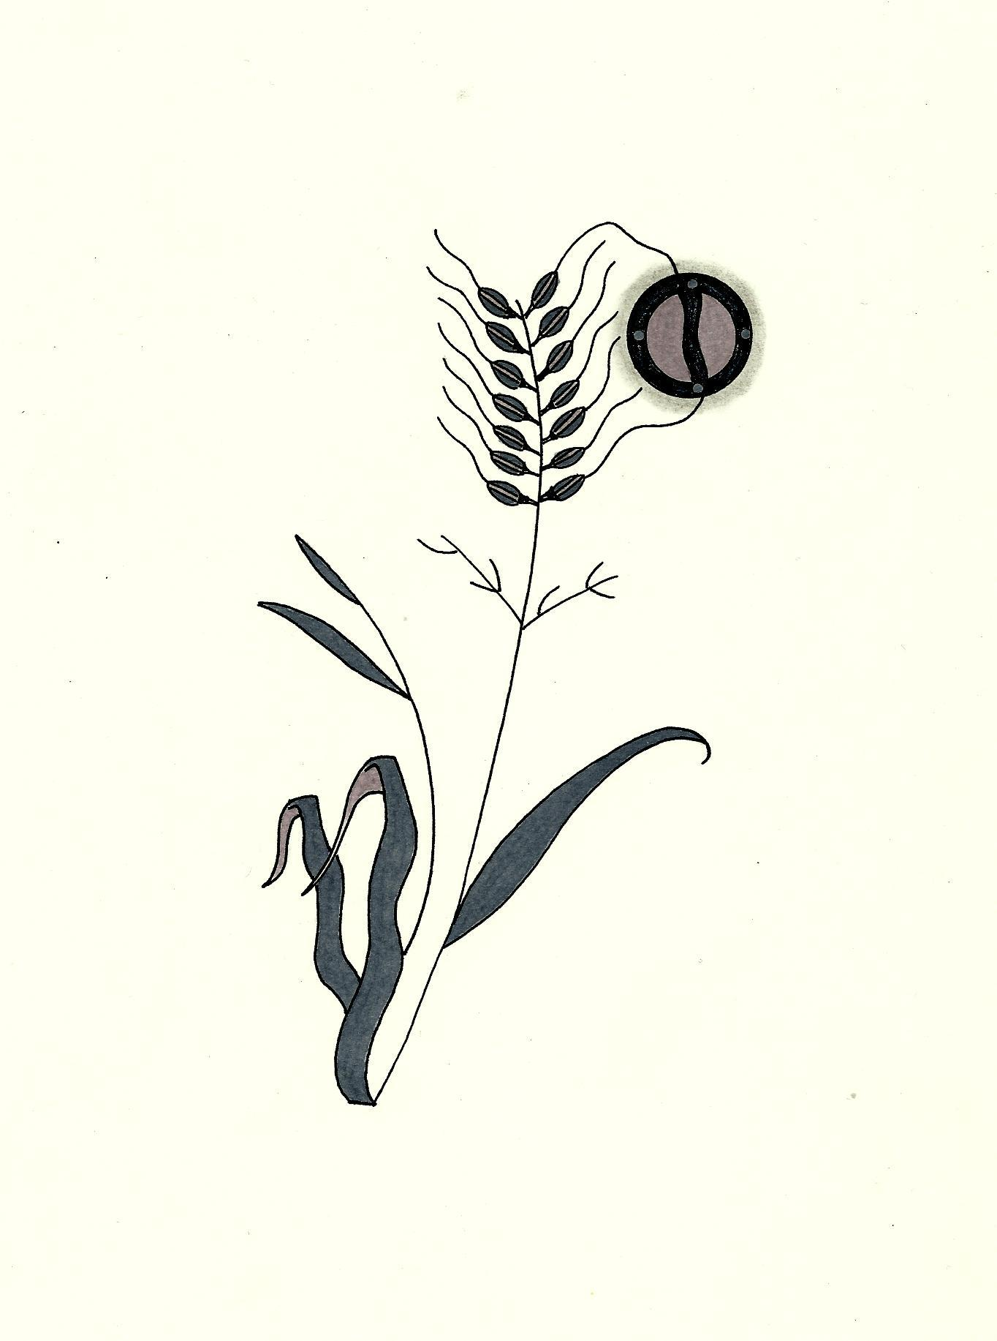

**Protect Our Manoomin**

**WWW.PROTECTOURMANOOMIN.ORG**

**NO MINE**

**NO COMPROMISE**