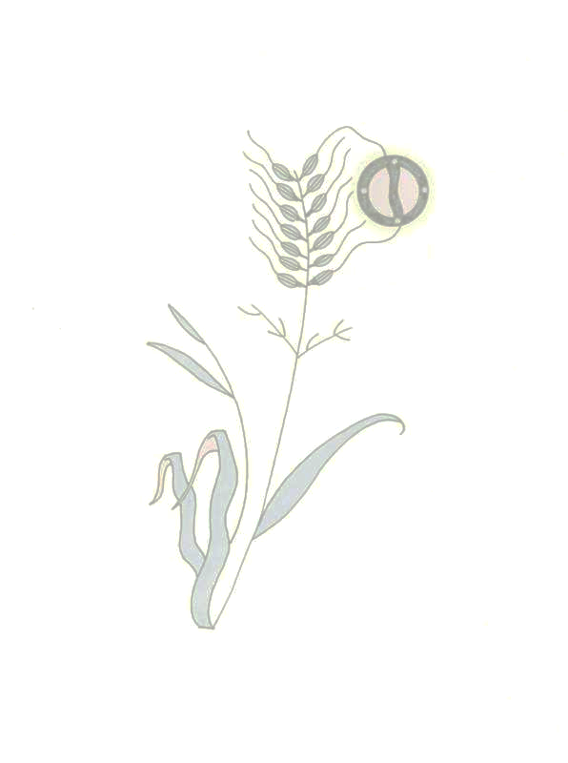
A Protect Our Manoomin Primer on PolyMet and Sulfide Mining

- Polymet is a foreign, Canadian extractive resource entity backed by Swiss multinational Glencore. Glencore has been cited for human rights abuses in the Congo and Columbia. Glencore currently owns about a quarter of PolyMet stock. Most of the copper from PolyMet’s mine will be exported to China.

- Environmental Protection Agency (EPA): “According to (PolyMet’s) DEIS (Draft Environmental Impact Study], all waste rock at the site is acid generating, and acidic water moving through waste rock and tailings will mobilize metals and sulfates, leaching them into groundwater and surface water…based on our review of the DEIS, EPA has rated the DEIS as environmentally Unsatisfactory – Inadequate. Environmentally Unsatisfactory (EU) indicates that our review has identified adverse environmental impacts that are of sufficient magnitude that EPA believes that the proposed action must not proceed as proposed.” (EPA Letter / February 2010)

- In the tribal response to PolyMet’s EIS, the three tribes involved - Bois Forte Band, Fond du Lac Band, and Grand Portage Band – cited incomplete and inadequate areas of study and the EIS didn’t meet state or federal environmental laws. The tribes also were adamant that the Wild Rice/Sulfate Standard be maintained to protect the manoomin.

- The proposed mine site is within the Superior National Forest, where open pit strip mining is not allowed under the Weeks Act. PolyMet will swap about 6,700 acres of public land with the Superior National Forest. Iron Range Resources provided PolyMet with a $4 million loan to buy the land that will be swapped.

- The mine will directly destroy more than 850 acres of high-quality wetlands with more than 650 additional acres of wetlands indirectly impaired. The total wetlands impact will be more than 1,500 acres. The vast majority of the required wetlands mitigation will occur outside the St. Louis River watershed.

- The mine is expected to generate nearly 400 million tons of waste rock and account for an annual carbon footprint of 767,648 metric tons of carbon dioxide emissions. Reactive waste rock piles will be permanently left on the land – ranging in size from 70 to 560 acres in size, and from 13 to 20 stories high. It will take 2000 years of water treatment to restore the water to the condition the water as in when the mining began.

- The project proposes to store mine tailings and toxic waste materials in an existing mine tailings basin that has current basin stability problems. The existing basin is located at Hoyt Lakes – 50 miles from Duluth. There is over 1800 acreage of manoomin located in the Hoyt Lakes area.

- The mining of less than 1% ores results in 99% waste rock. Mining the Duluth Complex of mineralization will ultimately destroy the most scenic part of northeast Minnesota between Lake Superior and the Boundary Waters Canoe Area Wilderness. This area includes approximately 9,000 acreage of manoomin.

- Even though mining companies are required to provide financial assurance for clean-up, the record from other states shows that clean-up costs far exceed projections, with tax payers footing the bill. In addition, financial assurance does not prevent the destruction of manoomin, forests, wetlands, water quality, wildlife habitat, scenic areas, and biodiversity.

- The metals mined will not be used for American technology. The demand for copper comes from China and is needed for building its industrial infrastructure. During this time of market disruption, China and newly industrializing countries are buying up copper and precious metals as a commodity to bolster their currency.

- In addition, the mining process adds sulfates, arsenic, and toxic heavy metals into the water.

- Copper mineralization is bonded to sulfide ores which eventually produce sulfuric acid. There is no copper mine in existence that is not polluting the ground water.
(Sources – Protect Our Manoomin, WaterLegacy, Friends of the Boundary Waters Wilderness,
Save Our Blue Sky Waters)

