A. Signature Rolls Red Lake Bands of Chippewa Indians, Minnesota

We, the undersigned, being adult Indians over eighteen years of age, of the tribes or bands occupying and belonging to the Red Lake Reservation, in the State of Minnesota, do hereby certify and declare that we have heard, read, interpreted, and thoroughly explained to our understanding, the act of Congress approved January 14, 1899, entitled – “An act for the relief and civilization of the Chippewa Indians in the State of Minnesota (Public No. 13), which said act is embodied in the foregoing instrument and after such provisions thereof, do hereby grant, cede, relinquish, and convey to the United States all our right, title, and interest in and to all and so much of said Red Lake Reservation as is not embraced in the following described boundaries, to wit:

Commending at the point on Thief River where the same crosses the line between Marshall and Polk Counties, thence easterly to the most northwesterly point of the upper Red Lake, thence easterly along the northerly shore of said upper Red Lake to a point due north of a point 1 mile east from the easterly end of the lower Red Lake, thence due south to the last-named point, thence southwesterly in a straight line to a point on Hay Creek 1 mile from where said creek enters the lower Red Lake, thence south to a point from which a line extending west passes midway between what is called the “big marsh” and the sugar bush north of and nearest to said marsh, said sugar bush being on the Red Lake and White Earth Road, thence west along said line between said march and sugar bush to Clear Water River, said line being supposed to be about 6 miles south of the lower Red Lake, thence northwesterly along Clearwater River to the point where said river crosses the boundary of Red Lake Reservation as the same heretofore existed, thence along said reservation line to the beginning, as designated on a map published in 1888 by Rand McNally & Co., of Chicago, Ill (but all waterways within the reservation described above are to be free for commercial purposes to all citizens of the United States), for the purposes and upon the terms stated in said act, which said lands embraced within the foregoing boundaries have been reserved by the commissioners appointed under said act and as therein authorized for the purpose of making and filing allotments therein provide for.

Witness our hands and seals hereto subscribed and affixed at the Old Red Lake Agency, on the Red Lake Reservation, in the State of Minnesota, on this 8th day of July, 1889.

Henry M. Rice [Seal],
Joseph B. Whiting [Seal],
Commission

B.P. Shuler,
United States Indian Agent

W.C. Hubbell,
Secretary to Commission

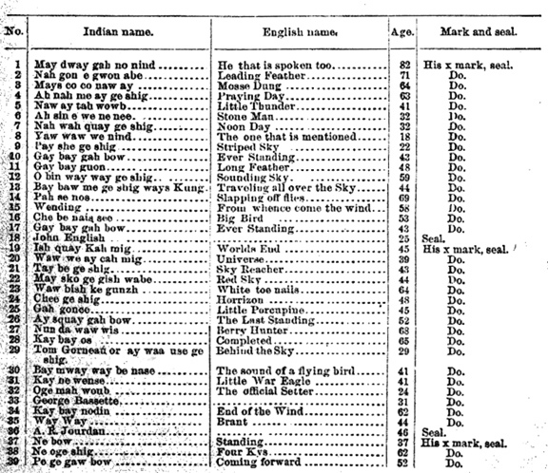

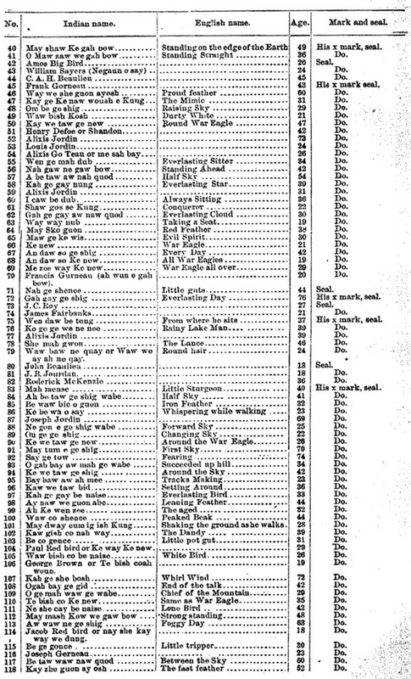
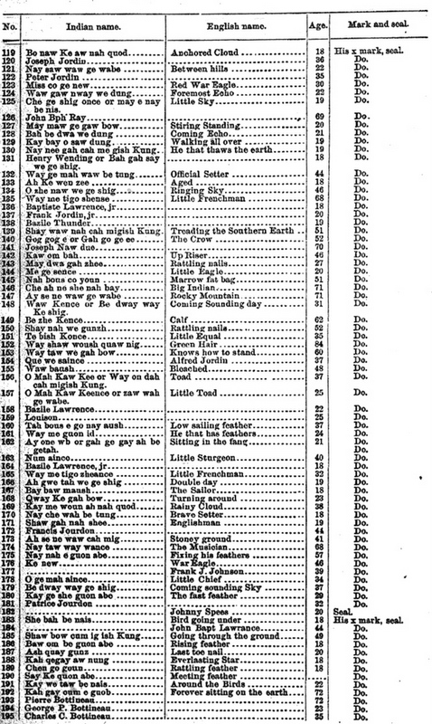

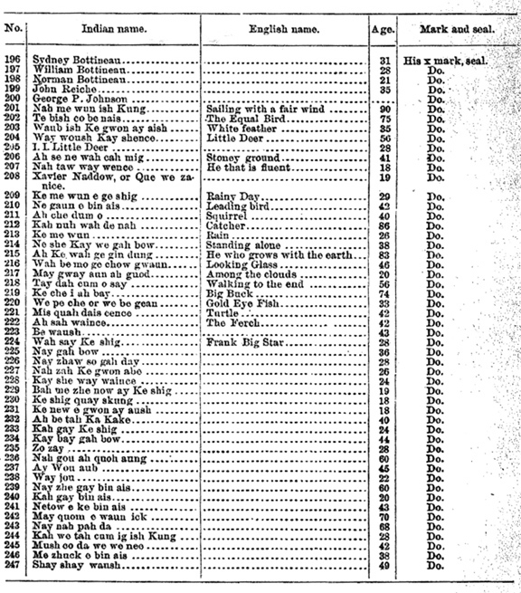
We hereby certify that the forgoing instrument was fully interpreted and explained to the Indians of the Red Lake Reservation whose names are subscribed and affixed thereto, and that we were present and witnessed the signatures of each.

P.H. Beaulieu
Interpreter to the Commission.
M.C. English,
Interpreter.
John English.
H.H. Beaulieu.
Red Lake Reservation, Minn., July 8, 1889

G.A. Morrison.
Robert Fairbanks
W.R. Spears
Red Lake Reservation, Minn., 1889

